If you're doing something semi-permanent, make sure you give users the ability to undo or cancel actions whenever possible.
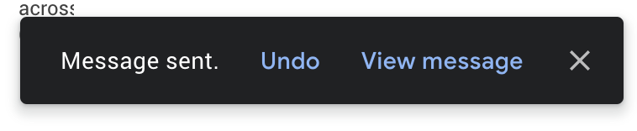
This toast notification from Gmail serves as an action confirmation and an undo opportunity for a few moments before your email goes out into the world.

Undo can be accomplished both proactively and reactively. Proactive undo scenarios are extremely common; most often, this comes in the form of a modal dialog asking “are you sure you want to do this?”

Reactive undo scenarios are a bit trickier with web-based applications, since edits and actions are often sent up to the cloud somewhere via API call, rather than being stored locally, where it’s easy to keep track of a list of recent actions in memory.

If you’re using “events” logic, which might well be how you are handling offline syncing, then this “undo” could be a case of removing the event from a queue. If you add delays to your queue (for certain events that are hugely destructive or scary like sending email) then adding a 30 second delay to the queue before the event is handled makes this undo work.

Another approach is to keep track of the relevant actions a user has taken by way of a queue structure in your database. Think of this as a table listing instructions for your application to take on behalf of a user. This can be useful in several ways - work completed on asynchronous actions can be tracked to completion, and annotated with error messages as necessary. You can also store the information needed to undo that action here. Finally, this can be presented back to your users as a historical log of their activity on your service.

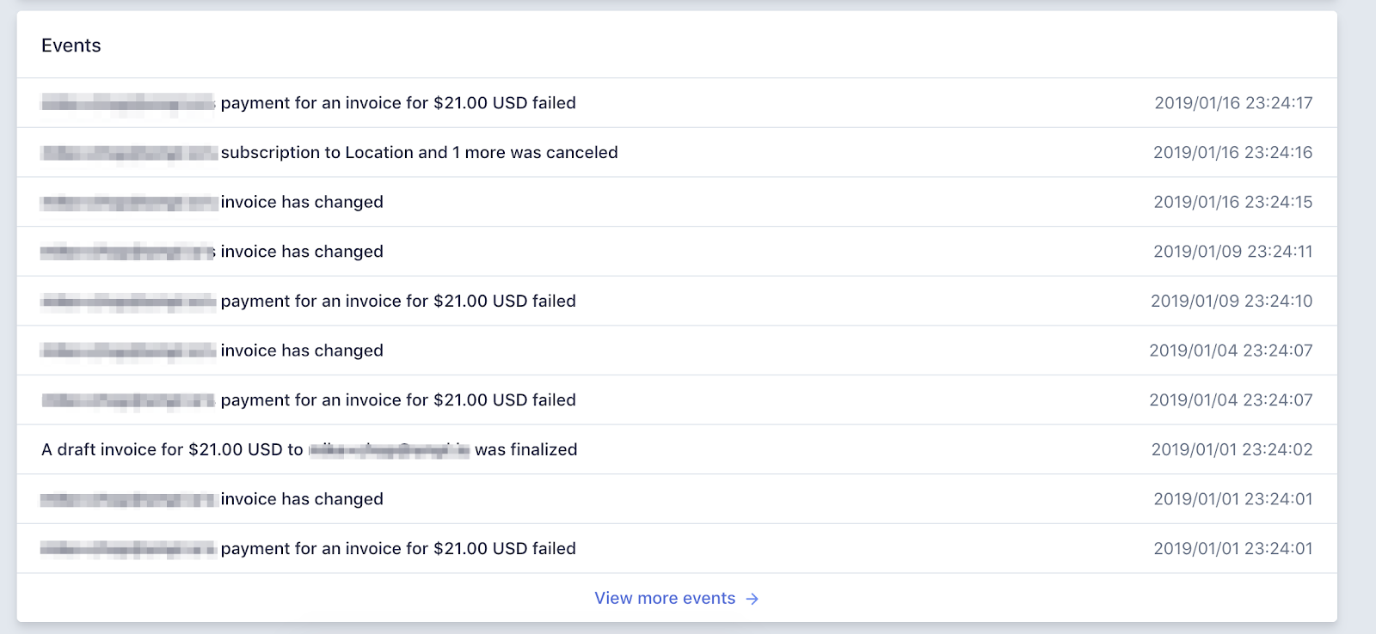
Stripe provides an Events log to customers using their service, which can be extremely helpful in tracking down failed and missing payments.

